Gabriel Smith
Feb 20, 2011

Analysis of Travelling Salesman Algorithms
Organization of the experiment:
For the OptimalTSP algorithm, I ran the algorithm on inputs as high as I could, before the runtime became unacceptably long. For the approximation algorithms, I ran the same inputs on all of them, ranging from 5 nodes to 10,000 nodes and compared the runtimes of each of them. All runs were done with a seed of 10,000. For the higher tests, I had to turn off the printing of the nodes, as that took more time to execute than running the actual algorithm. Unfortunately, an input of 10,000 caused a Heap Error in all of my algorithms, so 7,500 is the highest data point I could get.
Graphed Runtimes:
Input | Optimal TSP | GreedyTSP | MstTSP
2 | 9
4 | 83
6 | 83
8 | 272
10 | 453 | 4 | 4
11 | 683 | 4 | 4
12 | 1674 | 9 | 12
13 | 20142 | 18 | 18
20 |  | 33 | 29
50 |  | 89 | 48
100 |  | 233 | 90
500 |  | 1976 | 415
1000 |  | 22703 | 845
5000 |  |  | 7991
7500 |  |  | 15081

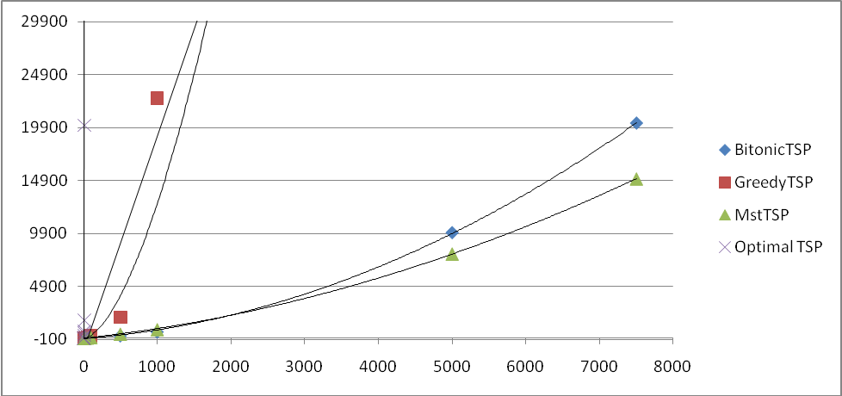
Surprisingly, the MstTSP seems to have performed better than the BitonicTSP at very high values, although they are still considerably faster than OptimalTSP and GreedyTSP.
Table of distances found
 | OptimalTSP | GreedyTSP | MstTSP | BitonicTSP
2 | 2.00 | 2.00 | 2.00 | 2.00
3 | 4.83 | 4.83 | 4.83 | 4.83
4 | 7.71 | 7.81 | 7.71 | 7.71
5 | 10.46 | 11.83 | 12.67 | 10.46
6 | 15.54 | 16.94 | 16.94 | 15.54
7 | 18.10 | 20.70 | 20.63 | 18.10
8 | 24.66 | 26.92 | 27.62 | 24.66
9 | 24.89 | 35.47 | 35.63 | 24.89
10 | 29.00 | 29.00 | 37.67 | 29.00
100 |  | 973.03 | 1069.96 | 1486.79
500 |  | 9573.90 | 11725.75 | 37613.90
1000 |  | 26625.79 | 32252.82 | 148891.13
:
Surprisingly, BitonicTSP managed to find the optimal distance for all values less than 10, at a significantly faster rate than OptimalTSP did. At high values though, MstTSP outperforms it, getting a more accutare distance in a faster time. GreedyTSP was the most accurate at high values, but the time cost associated with it may not be worth it.
Average Runtime for n=10
 | Average Runtime | Theoretical Runtime | Theoretical Constant
OptimalTSP | 321 ms | O(2^{n}) | c = 321/2¹⁰ = 0.313
GreedyTSP | 630 ms | O(n²) | c = 630/10² = 63.0
MstTSP | 642 ms | O(n lg n ) | c = 632/10lg10 = 19.3
BitonicTSP | 544 ms | O(n²) | c = 554/10² = 55.4

Through this method, it seems we are unable to determine a theoretical constant which applies to all algorithms. Each algorithm is strong with certain inputs, and a more efficient algorithm may end up running slower on the same input because of these strengths.
Clearly, each algorithm has its strengths and its weaknesses. OptimalTSP is useful when you absolutely must have the optimal solution, though it becomes incredibly unwieldy for values any higher than 15. GreedyTSP is good for medium values – between 10 and 100 where OptimalTSP begins to slow down. MstTSP seems to be the best for finding values in a reasonable amount of time, with decent accuracy. BitonicTSP found the optimal solution for all values under 10, and it would be safe to assume that it would continue to stay near-optimal for small inputs. At much higher inputs, BitonicTSP ran faster than the other algorithms, but gave up accuracy to do so.
This exercise in algorithms introduced me to several new methods of solving problems, and showed me how to judge a good algorithm from a bad one. As a future exercise, it would be interesting to see a combination of some of these algorithms in order to optimize runtime over a wide range of inputs.

